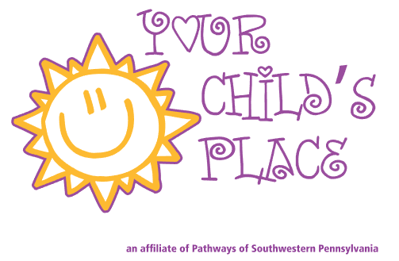

To: Valued Consumer

From: Your Child’s Place Personnel

As a valued active consumer of services Your Child’s Place pledges to protect your health information and understands it is of utmost importance. We respect your right to privacy and confidentiality as we work in tandem to reach your goals. In response to amendments in the Health Insurance Portability and Accountability Act (HIPAA) we revised our Privacy Notice, effective September 23, 2013, and attached a copy for your records. Rest assured Pathways complies with all aspects of this notice as our staff remains diligent in their handling of any information. Thank you for continuing to chose and trust us with your services.

Please return only this signed form to Your Child’s Place by: _________________
Specify Date

Include address or signature or use as desired………..

------------------------------------------------------------------------------------------------------------------------------
Acknowledgement

My signature below acknowledges receipt of Your Child’s Place Privacy Notice which
describes how my medical information may be used and disclosed, along with my rights.

Consumer’s Printed Name Consumer’s signature Date

Consumer’s Rep/Witness signature Relationship to consumer Date
(Provide only if Consumer is unable to sign)

--------------------------------------------------------------------------------------------------------------------------------

Your Child’s Place Personnel will complete information listed below:

Check one: Received signed document __________ witnessed signature/s ______

Your Child’s Place Personnel signature Title Date

9/6/13 KM

